Getting Started

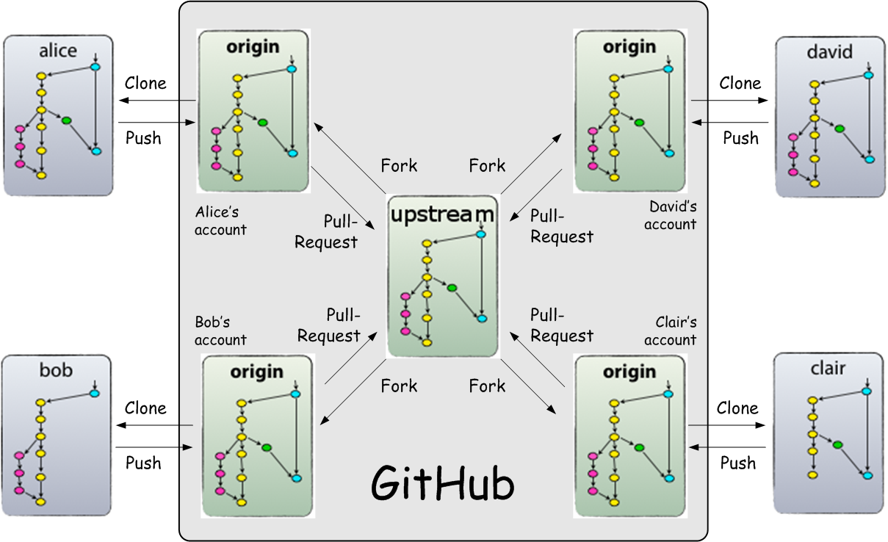

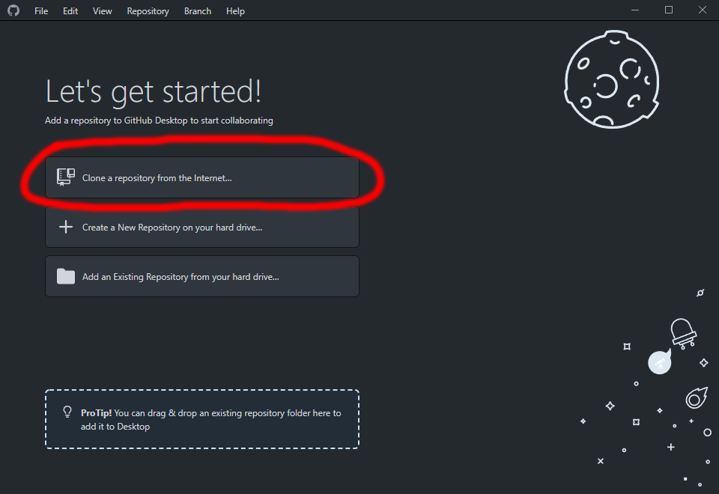

1. Clone the repository from Github

* You can clone a repository from GitHub.com to your local computer to make it easier to fix merge conflicts, add or remove files, and push larger commits. When you clone a repository, you copy the repository from GitHub.com to your local machine.

1. After hitting clone you will have to log into GitHub. From there just click on the repository that you want to clone and clone the repo

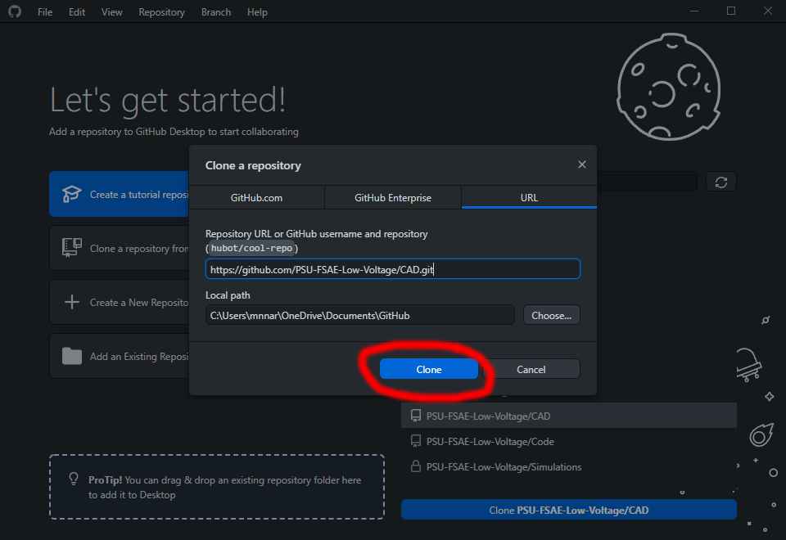

Reference docs if you need more help :

<https://docs.github.com/en/desktop/installing-and-configuring-github-desktop/overview/creating-your-first-repository-using-github-desktop>